18.33: We known that 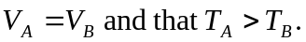
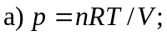 we don’t know n for each box, so either pressure could be higher.
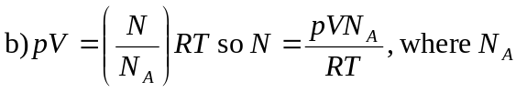 is Avogadro’s number. We don’t know how the pressures compare, so either N could be larger.

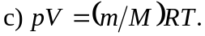 We don’t know the mass of the gas in each box, so they could contain the same gas or different gases.

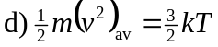
T_{A} > T_{B} and the average kinetic energy per molecule depends only on T, so the statement must be true.

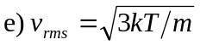
We don’t know anything about the masses of the atoms of the gas in each box, so either set of molecules could have a larger 